**Part 1**

Server

1. Build the socket and bind it to the server address and port.
2. Start listening on the socket and wait for client to request connection.
3. Whenever a client tries to connect, accept the connection. Receive the client message, modify the message, and send it back to the client.

Client

1. Build the socket.
2. Connect the socket to the server address and port.
3. Send the data to the server and wait for the server to send back data.

**Part 2**

sudo zmap -p 80 -b blacklist.txt -t 7200 -o zmap_results.csv

*Question 4:*

204.56.191.53 – Texas A&M University  
Address space: 128.194.0.0 - 128.194.255.255 = 128.194.0.0/16

Port 22: 4 Addresses

128.194.13.135

128.194.19.117

128.194.146.103

128.194.177.7

Port 25: 0 Addresses

Port 53: 2 Addresses

128.194.211.238

128.194.254.1

Port 80: 32 Addresses  
128.194.14.17

128.194.16.31

128.194.16.176

128.194.17.241

128.194.18.113

128.194.18.115

128.194.18.176

128.194.37.121

128.194.37.122

128.194.38.203

128.194.43.93

128.194.56.161

128.194.68.8

128.194.68.134

128.194.92.10

128.194.92.182

128.194.96.54

128.194.147.30

128.194.147.44

128.194.162.211

128.194.164.31

128.194.164.37

128.194.164.59

128.194.164.135

128.194.164.165

128.194.164.185

128.194.164.228

128.194.164.244

128.194.167.75

128.194.168.16

128.194.210.23

128.194.243.152

Port 443: 42 Addresses

128.194.0.135

128.194.4.56

128.194.4.58

128.194.14.43

128.194.14.51

128.194.14.54

128.194.16.6

128.194.16.57

128.194.16.61

128.194.19.15

128.194.19.54

128.194.19.82

128.194.19.109

128.194.19.170

128.194.34.42

128.194.34.43

128.194.34.46

128.194.36.230

128.194.42.175

128.194.43.93

128.194.54.12

128.194.54.64

128.194.56.134

128.194.59.245

128.194.92.145

128.194.92.146

128.194.144.216

128.194.146.17

128.194.146.219

128.194.147.20

128.194.162.21

128.194.162.30

128.194.162.32

128.194.164.31

128.194.164.55

128.194.164.186

128.194.177.117

128.194.183.107

128.194.210.23

128.194.210.159

128.194.243.237

128.194.245.27

Port 636: 1 Address  
128.194.43.42  
  
Port 990: 3 Addresses

128.194.92.14

128.194.92.154

128.194.164.64  
  
Port 993: 2 Addresses

128.194.17.74

128.194.19.171

These 3 addresses are open on both port 80 and 443:

128.194.43.93

128.194.164.31

128.194.210.23

On TAMU’s network, I was able to find ports used for SSH, DNS, HTTP, HTTPS, LDAP, FTPS, IMAPS.

Using HTTP queries, it appears that the first 8 bits of the subdomain are assigned based on department or service.

128.194.14.X: Authentication Services

128.194.16.X: Chemistry Department

128.194.19.X: Atmospheric Sciences Department

128.194.37.X: Orca

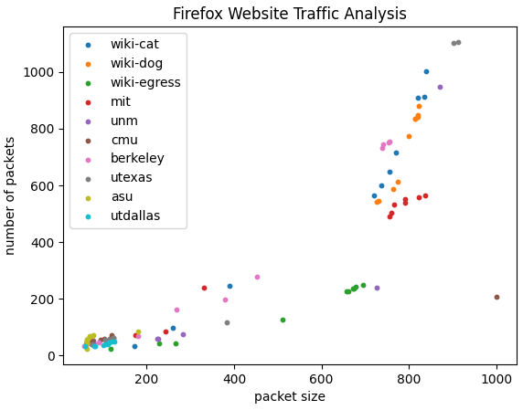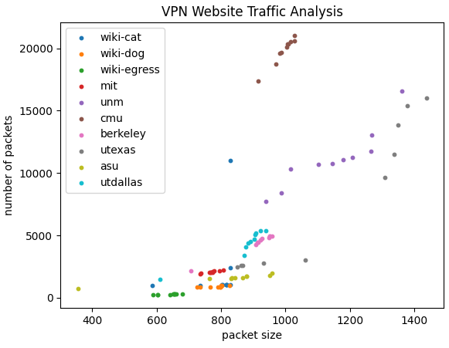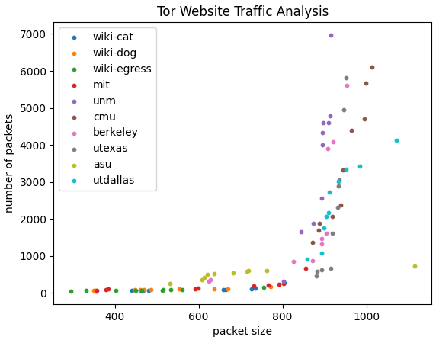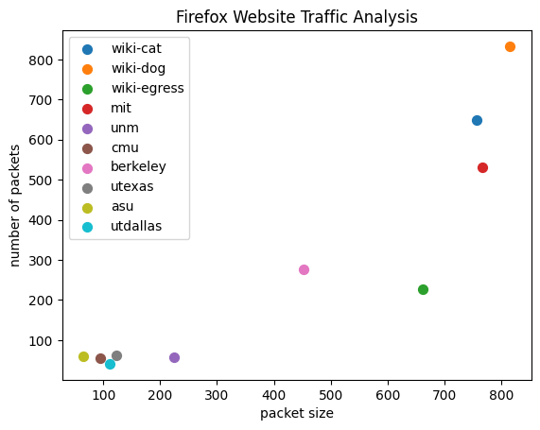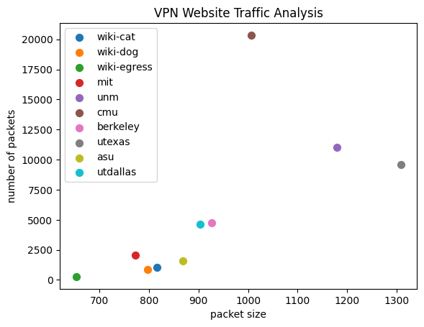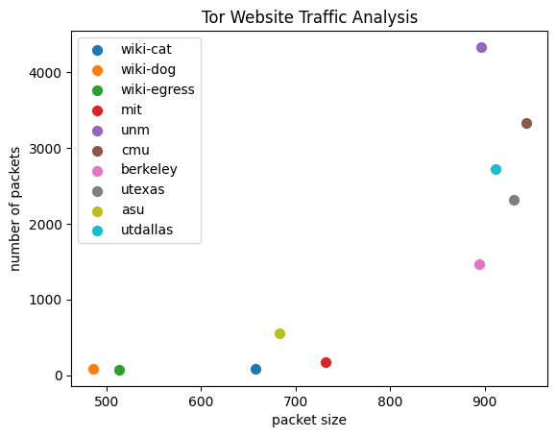

**Part 3**

* Each website query has a similar packet size and number of packets with its respective browser.
* Firefox on VPN requires the most amount of data, followed by Tor, then Firefox.
* Number of packets and packet size can vary greatly between queries.

For each connection type, what is visible to a passive device on the network?

* Firefox
  + Source/Destination IP
  + Source/Destination ports
  + Unencrypted Payload data (for HTTP)
  + Packet protocol / type
* VPN
  + VPN Server
  + Encrypted Payload Data
* Tor
  + Encrypted Source/Destination
  + Encrypted data

Can you use the connection statistics to determine which of the 10 websites was visited?

Yes, to a certain extent. Each website query has a large variance of packet size and number of packets between each query, even when using the same platform. It would take multiple queries to the same website to determine what website is being visited with confidence. The user querying the same website multiple times in a row is plausible since they may be navigating between pages on the same website.